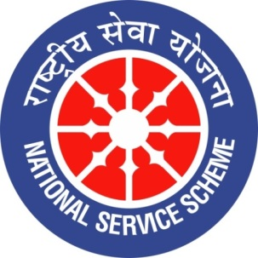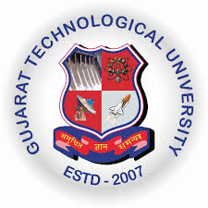
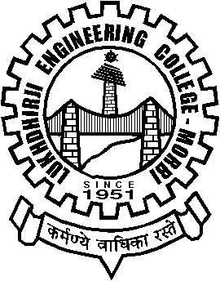
GUJARAT TECHNOLOGY UNIVERSITY
NATIONAL SERVICE SCHEME
Lukhdhirji Engineering College-Morbi
A Report on Visit to Kartavya Jivadaya Kendra on 24/09/2021 of L.E.College-Morbi

NSS Unit Name/College Name: L.E.College-Morbi
Event NAME: Visit to Kartavya Jivadaya Kendra
Event Date, Time and Location: 24/09/221, 4:00 pm, Kartavya Jivadaya Kendra , Morbi
Brief Description of the Event:
Hostel Department and NSS Cell has jointly organized an animal welfare activity. Kartvya Jivdaya Kendra is almost 9 km away from L.E.College, Morbi. They have take care of dogs, cats, snakes, rabbits and many birds. Vishubhai patel, animal lover and volunteer of this organization explained various activities. They rescue dogs, snakes and birds. They provide them food and also medical assistance. The L.E.College donated medicines for the animals. The expenditure of this program is met by the contribution from the rector, warden and assistant warden of hostel department. This program is done with Motivation of (Dr.) S.N.Pandya, Principal sir and under guidance of (Dr.) N.P.Singh, Rector sir. The event was coordinated by (Prof.) D.K.Mehta who is Program officer of NSS cell and warden of NVP boys hostel. All the wardens, assistant wardens, NSS volunteers and hostel students actively participated in this event.

Major Outcomes of Event:
- Medicines and food given to animals.
- Participants got idea how to rescue various animals.
- Participants came to know about various laws regarding animals.
- Participants motivated and committed work towards animal welfare.
Photographs of the Event:

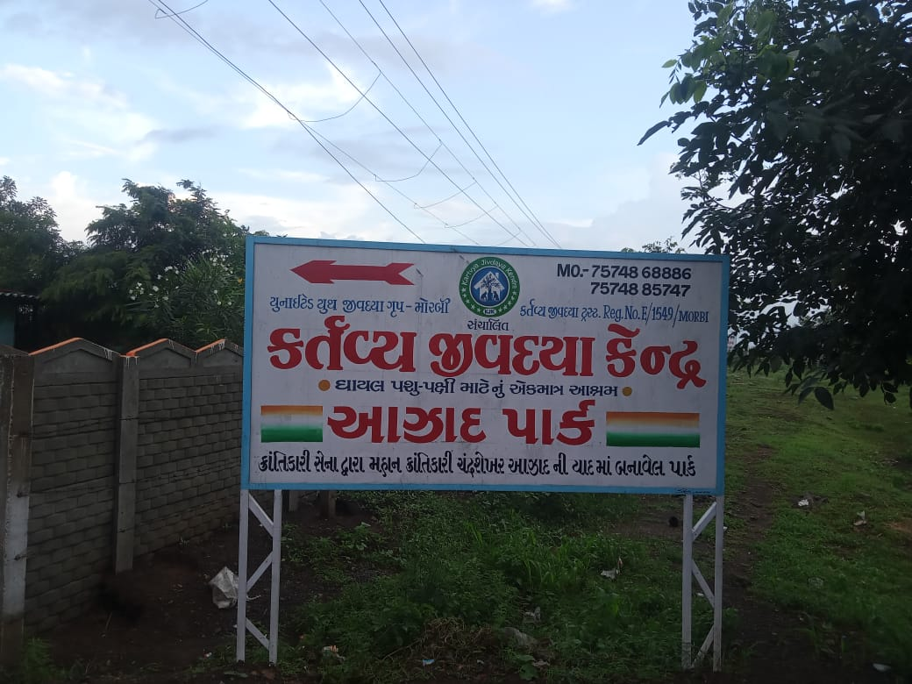
Location of place
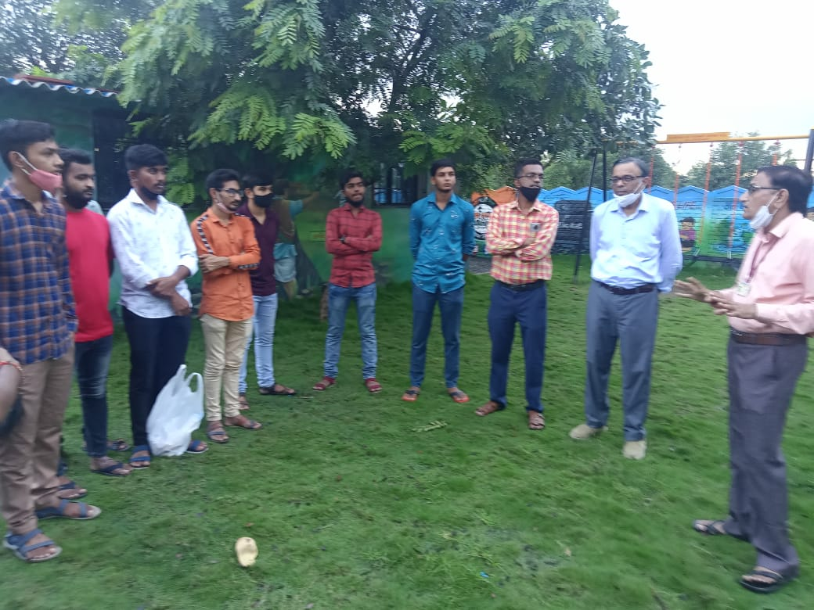
Participants
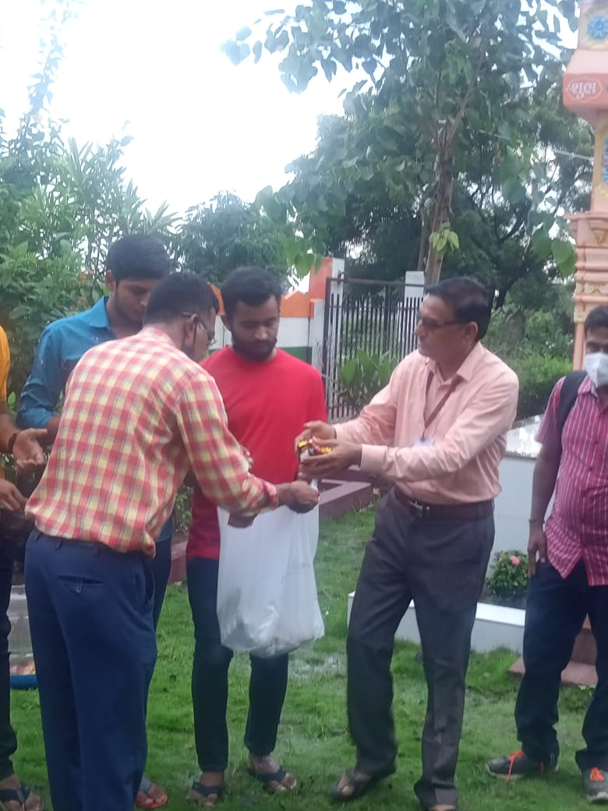
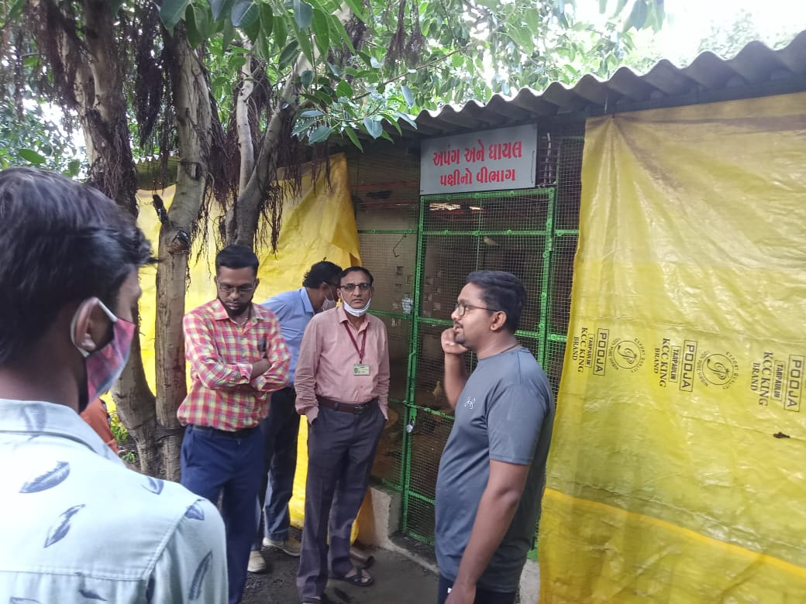
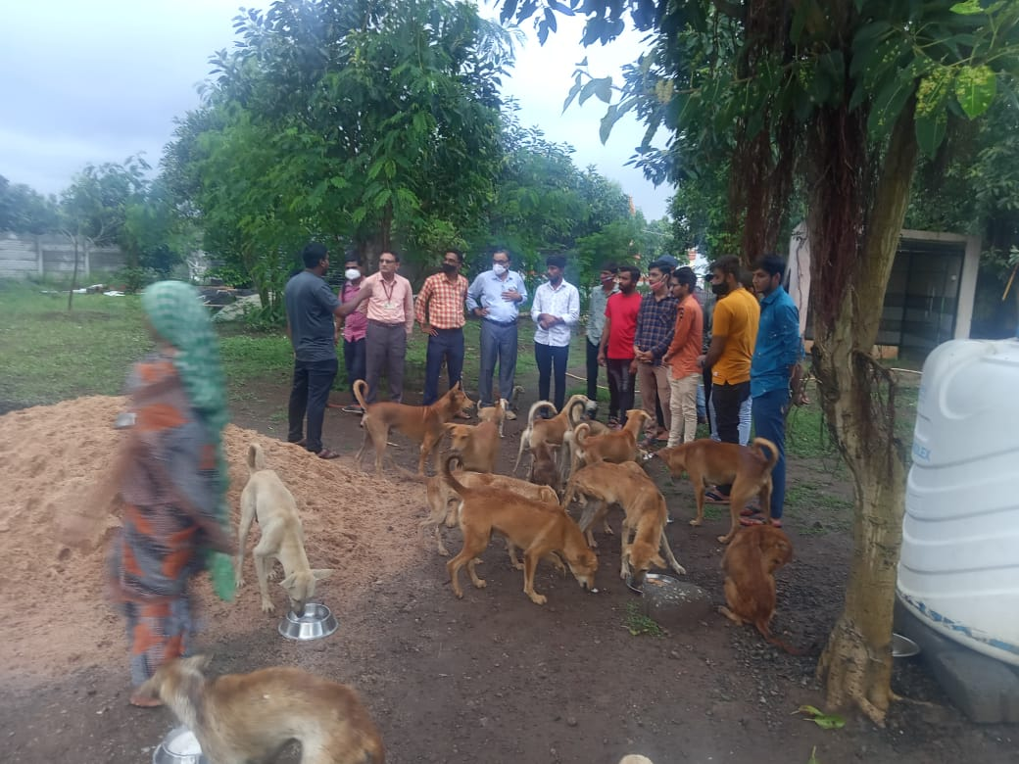
Pics of various parts of Kartavya Jivdaya Kendra

